Weather radar-based supercell tracking: The case of 10 July 2019, Macedonia, Greece
Karoutsos G.¹, N.R. Dalezios², M. Spiliotopoulos², I.N. Faraslis³ and M. Sioutas⁴
¹General Aviation Applications - 3Ds.a., Thessaloniki, Greece
² Department of Civil Engineering, University of Thessaly, Volos, Greece
³ Department of Environmental Sciences, University of Thessaly, Larisa, Greece
⁴ Meteorological Applications Center of ELGA, Thessaloniki, Greece
Abstract. Supercell thunderstorms are among the most destructive weather phenomena worldwide, which, under certain conditions, can be deadly. A supercell can be defined as a thunderstorm characterized by the presence of a mesocyclone. Supercells are usually found isolated from other thunderstorms or embedded in a squall line. Typically, supercells are found in the warm sector of a low-pressure system. A single supercell storm can cause a very serious economic destruction from flooding to severe property damage, or loss of lives. At this study, the case of a supercell is examined, which entered Greece from the north west part of Florina, went through west and central Macedonia and ended in South Halkidiki and the peninsula of Kassandra lasting more than three hours. Specifically, during the last evening hours of Wednesday, July 10, 2019, storms of specific severity, accompanied by fierce winds and in some cases by hail of large dimensions, hit the study area. The most severe phenomena were recorded in the prefecture of Halkidiki, where seven people were killed, 120 people were injured and large devastation occurred. This supercell was tracked and monitored by the weather radar of 3D S.A., Greece. Indicatively, the maximum recorded radar reflectivity was 71 dbz and the maximum storm height was 16.6 km.

1 Introduction
Thunderstorm is called a towering cumulus cloud with strong updrafts and downdrafts, accompanied by lightning and thunder. A thunderstorm is driven by convection, in which moist warm air rises aloft within a cooler environment. The thunderstorm is variously referred to as a “convective storm”, "convective cell", or "convection", since it is created by a violent upsurge of warm, buoyant, convective air currents from the lower atmosphere to altitudes as great as around 15 kilometers above mean sea level (MSL). The intense, buoyantly forced rising motions in the thunderstorm, generated by the temperature difference between the warm cloud and the relatively cold surrounding environment, namely convective instability, produce thick cloud and heavy precipitation. Adopting the definition of "mesoscale" (Orlanski 1975), individual thunderstorms are typically meso-γ-scale in horizontal dimension (2-20 km), whereas an organized mesoscale convective system (MCS) is typically meso-β-scale (20-200 km) or larger in width.
In this paper, the case of a supercell storm is analyzed, which entered Greece from its north west part, went through west and central Macedonia and ended in South Halkidiki and the peninsula of Kassandra lasting more than three hours. Specifically, on July 10, 2019, storms of extreme severity, accompanied by fierce winds and in some cases by hail of large dimensions, hit the study area. The most severe impacts were recorded in the prefecture of Halkidiki, where seven people were killed, 120 people were injured and extensive devastation occurred. This supercell was tracked and monitored by the weather radar of 3D S.A., Greece. Indicatively, the maximum recorded radar reflectivity was 71 dbz and the maximum storm height was 16.6 km. The paper is organized as follows: In section 2, storm classification and monitoring are considered, which involve classification of storms and storm tracking methods. In section 3, the case of supercell tracking of 10 July 2019 in Macedonia Greece is analyzed, which includes data base description (synoptic meteorological condition and weather radar data) and presentation of the supercell features mainly based on weather radar.

2 Storm Classification and monitoring
2.1 Classification of storms
There are many valid ways to classify storms. For instance, according to a meteorological approach, atmospheric phenomena are often differentiated based on their scale, i.e. microscale, mesoscale and synoptic scale. Similarly, a natural hazards approach, also called a geophysical process, typically focuses either on specific phenomena, such as hurricanes, floods, or blizzards, or on decision processes of various aspects, such as warning and response, risk assessment, or mitigation. Ideally, a combination of these approaches can be adopted (Krauss and Dalezios, 2017). Convective storms can be classified as isolated storms or MCSs. Indeed, large-scale storms are differentiated by their physical characteristics into tropical cyclones, extratropical cyclones and MCSs. The thunderstorm is the basic element or “building block” of the MCS. MCSs include squall lines and mesoscale convective complexes (MCC). It is also known that many types of rainstorms and hailstorms exist. Specific types of isolated storms include single-cell storms, multicell storms, and supercell storms.
Single-cell storms represent small rain showers and thunderstorms typically covering an area of a few kilometers or less and having a lifetime of less than an hour. Multi-cell storms consist of several convective cells or single-cell storms at different stages in their lifetime, within the same complex and possibly including supercells. Thus, the multi-cell system may have a lifetime much longer than that of any individual cell. The areal extent of the system may be much larger than that of a single cell and thus may cover a larger portion of the drainage area for a small watershed. Supercell storms occur under conditions of strong environmental wind shear in both direction and speed, and strong instability. In this case, a very large single rotating cell may develop with a single main updraft 5 km or more in diameter with updraft speeds in excess of 50 m s⁻¹. The change in wind direction and speed with height helps to separate the cloud updraft from the downdraft, which leads to longer cell lifetimes of the order of several hours. Supercells are large and intense and process vast amounts of air and moisture. Supercells often occur in conditions with strong winds aloft and so may move rapidly. Frontal boundaries, gust fronts or topography may also alter storm movement. The great strength of the updraft in supercells may cause most of the moisture to be transported to high altitudes and out into the storm anvil (Chisholm and Renick, 1972). However, if the low-level inflow air is rich in moisture, very large volumes of rainfall may be produced. Known as quasi-steady-state storms, they are the most severe type of thunderstorms. Supercell storms, unlike multi-cell storms, generally feature a single, large, rotating updraft zone. They have extremely high damage potential, as they can cause not only strong wind gusts and heavy precipitation, but also large hailstones and tornados.

2.2 Storm tracking methods
Α largely unsolved problem in MCSs forecasting involves anticipating the timing and location of convective initiation. Experimental forecasters can produce operational daily forecasts of deep convection (Dalezios and Papamanolis, 1991). However, since storms often form within a range of 10-20 km of mesoscale boundaries, which may themselves be meso-γ-scale or narrower in width, variability in the boundary layer is probably critical for the storm initiation process along with formation, structure and movement. There are radar-based storm tracking and forecasting methods, which include extrapolation methods, knowledge-based nowcasting methods, numerical models, neural network models and further approaches, such as probability forecasts and modified turning band (MTB) models (Krauss and Dalezios, 2017). Specifically, extrapolation methods include steady-state assumption methods, which involve cross-correlation and feature tracking methods, as well as echo size and intensity trending methods. Nowcasting and forecasting of radar echo motion requires determination of their velocity and direction of displacement. Many radar-based methods use tracking algorithms based on pattern recognition, either determining the echo motion through cross correlation (Austin and Bellon, 1974) or tracking specific features of the radar echo (Browning et al., 1982). Problems with tracking algorithms are mainly caused by small-scale and short-term variations of the radar echo pattern, e.g. orographic impacts and radar technical limitations. Α further approach for advecting radar echoes is by using winds from the steering level, which can be provided by outputs of Doppler radar measurements (Andersson, 1991).
Cross-correlation method. Cross correlation method is used to determine the overall motion of radar echoes. Similar patterns of radar echoes are detected by comparing tracking areas in consecutive scans. The best fit between the tracking areas is found by optimizing the correlation cοeffιcient. The distance between the tracking area and the time lag of the scans determine the displacement vector. Figure 1 shows how the cross-correlation method works through an idealized sequence of radar-detected precipitation patterns at times (t₁ – Δt), t₁ and (t₁ + Δt) (Austin and Bellon, 1974). The vector AB represents the forecasted motion of the center of gravity between (t₁ – Δt) and t₁. Specifically, the direction of the vector AB is found by selecting the highest cross-correlation among all the computed cross-correlations between the center of gravity A and all the adjacent pixels and the distance AB is found based on the pattern’s speed. The vector BC represents the correction obtained using the cross-correlation technique leading to AC as the measured displacement vector. Note that the forecasted shape of the pattern remains the same, which is being adjusted with each measurement. CR is the forecast translation vector, which in this case is equal to AC. Similarly, RO is the difference between the forecast vector CR and the actual motion CO. There have been various extensions to the basic idea. Specifically, the 2-D continuity equation was applied to eliminate divergent components of the derived displacement vector field, such as erroneous vectors caused by clutter, shielding, rapid changes in the radar pattern (Li et al., 1995). Moreover, a geometric algorithm was added to provide a possibility to detect merging and splitting cells (Dixon and Wiener, 1993). Also, an approach was implemented combining cross correlation and feature identification (du Vachat et al., 1993).
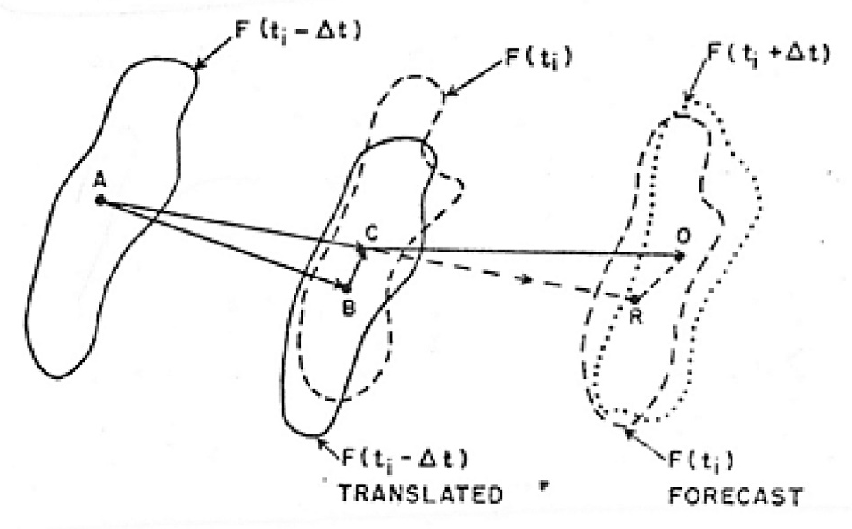
Figure 1. Schematic view of the cross-correlation method for storm tracking (Austin and Bellon, 1974).
TITAN (Thunderstorm Identification, Tracking, Analysis and Nowcasting) software: TITAN combines the advantages of both, cross correlation and mass centroid approaches (Mecklenburg, 2000; Dixon and Wiener, 1993). The mass centroid method was applied to identify storms considered as ‘’three- dimensional entities”. Το track them in time, they used a combinatorial optimization based part1y οn the cross correlation approach. Additional geometric algorithms provide the possibility to detect merging and splitting cells. The forecast was carried out using a weighted linear fit from the storms’ history for both position and size.

3 Supercell tracking: the case of 10 July 2019 in Macedonia Greece
In this section, a brief analysis is presented of the supercell storm features that affected Macedonia Greece with devastating damages. This storm has been classified as supercell, since it covers all the characteristics of a supercell storm. At first, the data base used in this paper is presented, namely synoptic meteorological condition and weather radar specifications. This is followed by a brief analysis of the supercell tracking features based mainly on weather radar recordings.

3.1 Data base: Synoptic Meteorological conditions and weather radar specifications
The data base used in this paper includes the synoptic meteorological conditions of 10 July 2019 and the specifications of the C-band Doppler weather radar at Filiro Thessaloniki (FIL). Specifically, Figure 2 (left) presents the surface meteorological analysis chart of 12.00Z, 10 July 2019, where a low pressure center (1005 hPa) is delineated just north-west of Greece, along with a front, which are ahead of a trough over Italy on the 500 hPa analysis chart of 12.00Z, 10 July 2019 (Figure 2-right). Similarly, Figure 3 (left) delineates the tephigram of 00.00Z, 10 July 2019, at Thessaloniki (Airport), which shows a large positive energy area indicating strong atmospheric instability. Figure 3 (right) presents some specifications of the Filiro radar.

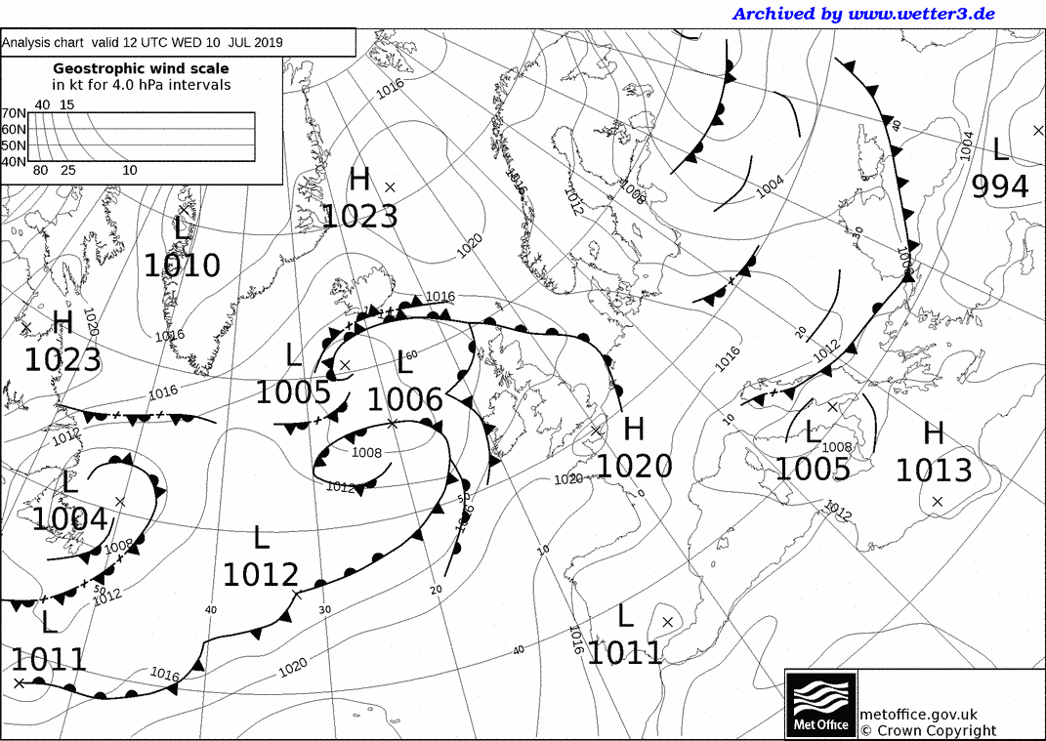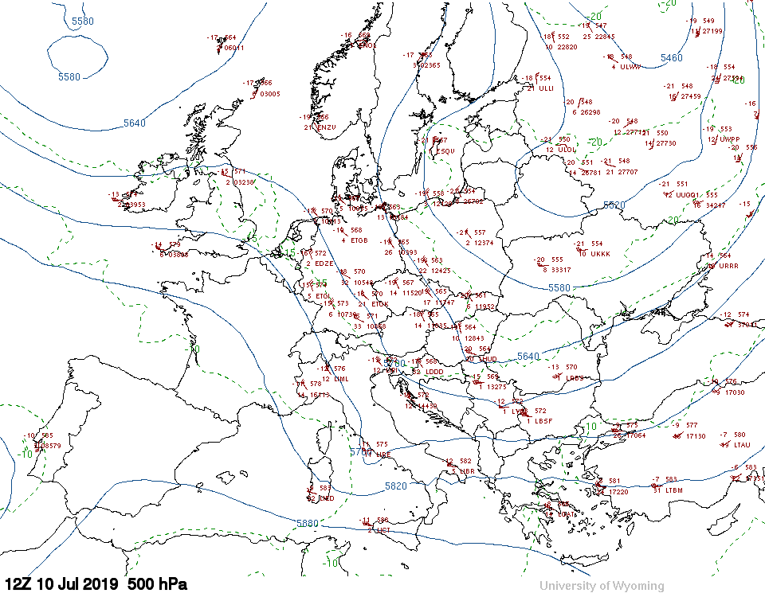
Figure 2. (left) Surface meteorological analysis chart of 12.00Z, 10 July 2019 (by UK Met Office); (right) analysis chart of 500 hPa of 12.00Z, 10 July 2019 (by UK Met Office).

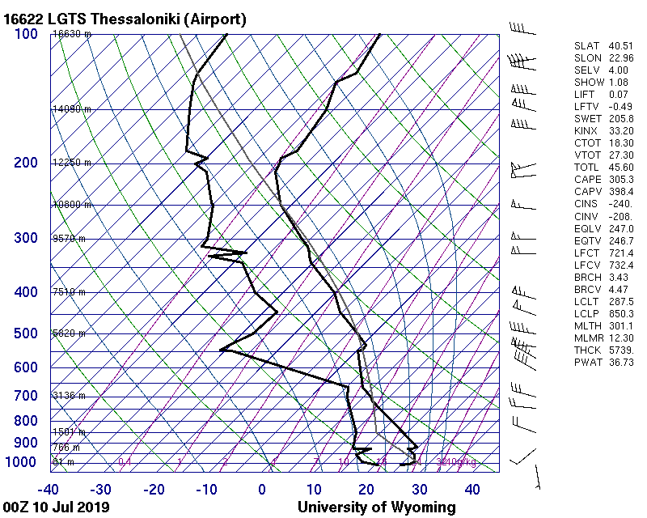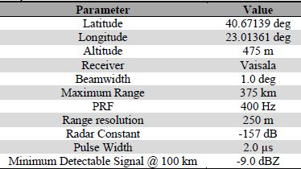
C-band Doppler weather radar specifications at Filiro Thessaloniki (FIL)
Figure 3. (left) Tephigram of 00.00Z at Thessaloniki (Airport), 10 July 2019 (University of Wyoming);
(right) C-band Doppler weather radar specifications at Filiro Thessaloniki (FIL).

3.2 Tracking features of the supercell storm of 10 July 2019
Tracking of the supercell storm is presented through Figures 4 and 5 and Table 1. Specifically, Figure 4 tracks the maximum reflectivity of each weather radar scan (every 3 minutes) throughout the supercell storm activity over Macedonia Greece, which entered north-west Greece at 16.34Z and left the region of Halkidiki-Macedonia at 19.55Z, 10 July 2019, as shown in Figure 4. Table 1 presents several weather radar parameters and features in selected tracking steps of the supercell storm of 10 July 2019. From Table 1 and Figure 4 it
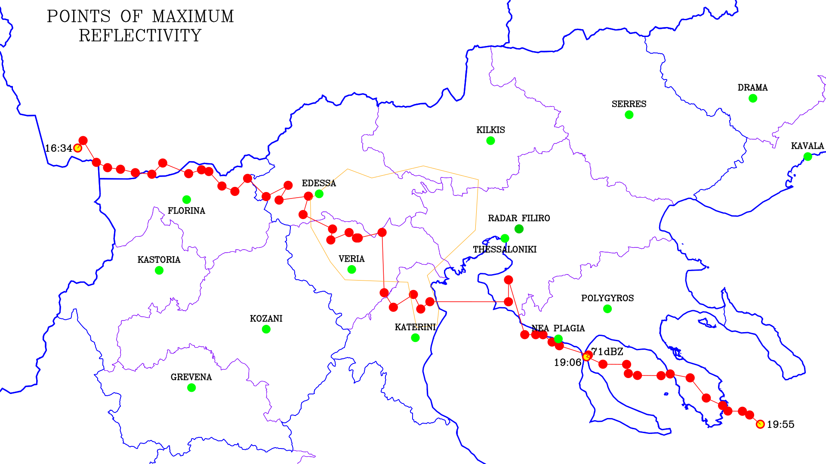
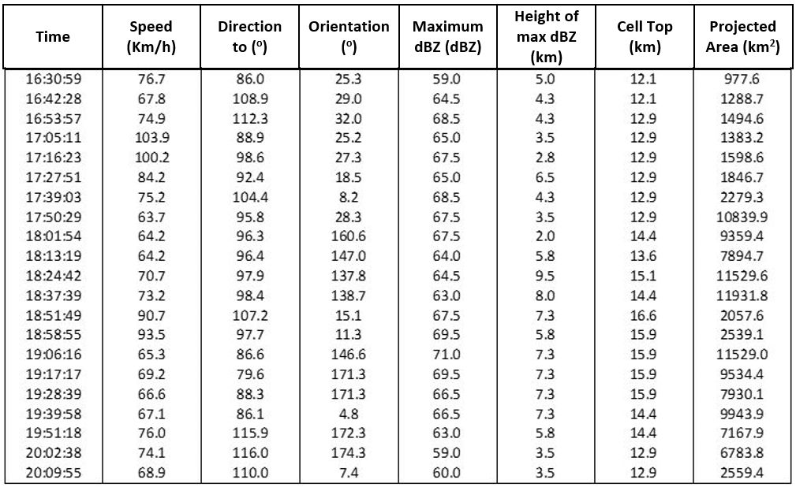
Figure 4. Weather radar-based supercell storm tracking of maximum reflectivity-10 July 2019.
Table 1. Weather radar features and parameters of tracking the supercell storm of 10 July 2019.

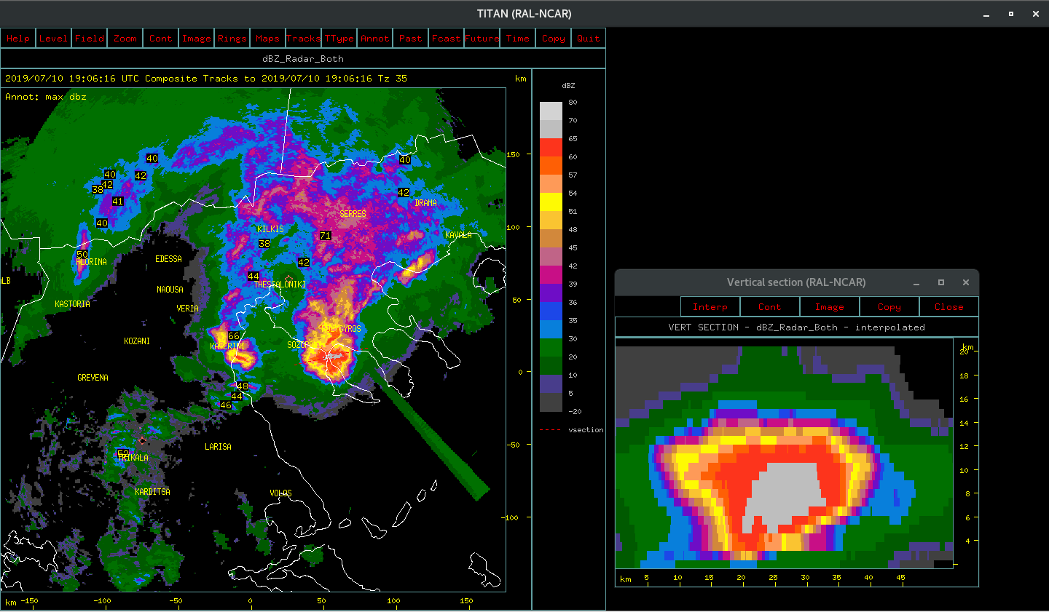
Figure 5. (left) PPI (Plan Position Indicator) of weather radar echoes of 19.06Z, 10 July 2019; (right) RHI (Range Height Indicator) of weather radar echoes of 19.06Z, 10 July 2019.
Is recorded that the supercell storm moved from north-west to south-east. The maximum recorded cell top was 16.6 km with 67.5 dbz at 18:51:49Z. Moreover, the maximum recorded reflectivity was 71.0 dbz at a height of 7.3 km with cell top at 15.9 km and projected area of 11,529 km² at 19:06:16Z (Table 1). Figure 5 (left) presents the PPI (Plan Position Indicator) of weather radar echoes at 19.06Z, 10 July 2019, which is the time that maximum reflectivity occurred; and Figure 5 (right) shows the RHI (Range Height Indicator) of weather radar echoes again at the time of maximum reflectivity, 19.06Z, 10 July 2019.

4 Summary
In this study, tracking of a supercell storm is considered, based on weather radar features, which entered Greece from the north west part of Florina, went through west and central Macedonia and ended in South Halkidiki and the peninsula of Kassandra lasting more than three hours. This supercell storm was of exceptional severity, accompanied by fierce winds and in some cases by hail of large dimensions reaching a record high reflectivity of 71.0 dbz.

Acknowledgements
The weather radar data was provided by 3DSA. The research was funded by the National Hail Suppression program of Greece and the recently approved program by GSRT, Greece, entitled EXTREMES.

References
Andersson, Τ., 1991. Αn advective mοdel for probability nowcasts of accumulated precipitation using radar. In: I.D. Cluckie and C.G. Collier (eds.), Hydrological applications of weather radar, Ellis Horwood, England, 325-330.
Αustin, G.L. and Bellon, Α., 1974. The use of digital weather radar recordsf for short-term precipitation forecasting. Quart. J. Roy. Μeteorol. Soc., 100, 658-664.
Browning, Κ.Α., Collier,C.G., Larke,P.R., Menmuir,Ρ., Monk, G.A and Owens, R.G., 1982. On the forecasting of frontal rain using a weather radar network. Mo. Weather Rev.,110,534-552.
Chisholm, A.J., and J.H. Renick, 1972: The kinematics of multicell and supercell Alberta hailstorms. Alberta Hail Studies, 1972, Alberta Research Council Report 72-2. 24-31.
Dalezios, N.R. and N.K. Papamanolis, 1991: Objective Assessment of Instability Indices for Operational Hail Forecasting in Greece. “Meteorology and Atm. Physics”, 45, 87-100.
Dennis, A.S., M.A. Schock, A. Koscielski, 1970: Characteristics of hailstorms of Western South Dakota. J. Applied Meteorology, 9, 127-135.
Dixon M. and Wiener. G., 1993. ΤΙΤΑΝ: Thunderstorm identification, Tracking, Analysis. and Nowcasting-A Radar-based Methodology, J. Atmos. Oceanic Technol., 10, 785-797.
Du Vachat, R., Τhomas, Ρ., Bocrie, Ε., Μοnceau, G., Cosentino, Ρ., Senesi. S., Tzanos, D. and Boichard, J.-L., 1995. The precipitation nowcast scheme in the Aspic project. In Proc. Second European Conf. On Applications of Meteorology. Toulouse, France, 29-32.
Krauss, T and N.R. Dalezios, 2017: Storms. Book chapter 3, in: Environmental Hazards Methodologies for Risk Assessment and Management. Editor: N.R. Dalezios, Publisher: IWA, London UK, 95-136.
Lί. L., Schmid, W. and Joss, J., 1995. Nowcasting of motion and growth of precipitation with radar over a complex orography. J. Αppl. Meteor., 34, 1286-1300.
Mecklenburg, S., Joss, J. and Schmid, W., 2000. Improving the nowcasting of precipitation in an Alpine region with an enhanced radar echo tracking algorithm. J. Hydrol. 239. 46-68.
Orlanski, I. 1975. A Rational Subdivision of Scales for Atmospheric Processes. Bulletin AMS, Vol. 56 (5), May, 527-530.

